Documentation

Development of employment levels (geringfügige Beschäftigung):



🡪 many, but not all, Bundesländer have seen an increase in the employment level for low wage work since the wave of refugees

Development of the number of refugees relative to the population in each Bundesland:



Difference in Refugees relative to the Population between 2014 and 2016:

Ein Bild, das Tisch enthält.

🡪 two Bundesländer which would be good for comparison are Mecklenburg-Vorpommern and Schleswig-Holstein as they are very comparable since they are located next to each other and have a comparable size. Also they are on opposite ends regarding the change in refugees per population

🡪 another idea would be to compare Mecklenburg-Vorpommern and Bremen since they took in the least and most refugees relative to their population, respectively. However, one is a city and one is not densely populated so they may not be directly comparable.

Development of refugees relative to the population in Germany and Switzerland:



🡪 we can see that Germany took many more refugees in than Switzerland

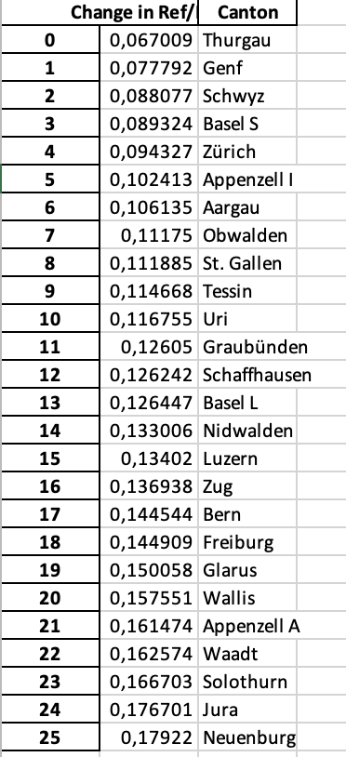

* Genf & Waadt oder Solothurn & Aargau

Results National Data

In order to validate the necessary common trend assumption, we looked at the development over time of the unemployment rate, the total employment level and the employment level of foreigners in Germany and Switzerland.

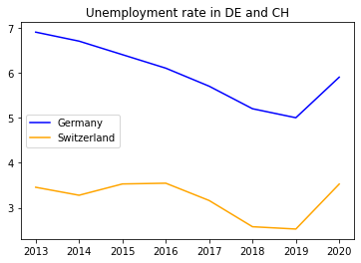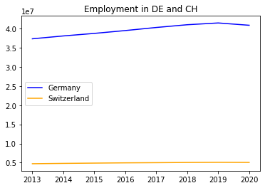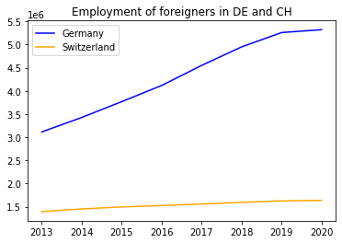

As one can see, the trends pre-2015 are similar but not all the same. However, we can make the assumption that Switzerland and Germany are comparable since they have similar demographics, institutions etc.

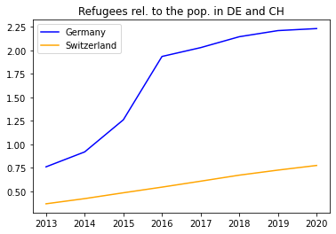

When we look at the number of refugees relative to population size, we can see a development as expected. The numbers in Germany increase exponentially from mid-2014 while they only increase linearly in Switzerland. After 2016 this exponential trend levels off.

Next, let us look at the results of the ATET estimation.

The ATET for **Total Empl is 1,262,062**

The ATET for **Total Empl Foreigners is 616,629**

The ATET for **Unemployment Rate is -1.0**

Assuming that all identifying assumptions hold, we can see that the influx of employees led to an increase in the total employment level by approximately 1.3m and an increase in the employment level for foreigners by approximately 0.6m. It is interesting that the effect is almost twice as large on the total level of employment. Perhaps this is because the refugees took on jobs in industries which were either desperately in need of workers and/or which are supporting industries to other industries, hence, boosting the total employment level. Considering that between 2014 and 2016 there was an influx of ﻿851,250 refugees, we can make the assumption that many of them found work since the size of the ATET for the employment of foreigners is ﻿72.4% as large as the increase in refugees. Of course, not all of the ATET is due to refugees alone but also other foreigners living in Germany.

And finally, we can have a look at the effect of the influx of refugees on the employment level of low-wage jobs (“geringfügige Beschäftigungsverhältnisse”). This was estimated with an OLS regression where *Total Empl (geringfügig)* is the dependent variable. As independent variables we chose *Total Population, Total refugees, without educ* and *Year* since the low-wage employment level can also be influenced by the development of the total population as well as the number of people without education.

OLS Estimation Results:

--------------------------------------------------------------------------------

Dependent Variable: Total Empl (geringfügig)

--------------------------------------------------------------------------------

coef se t-value p-value

intercept 1.847465e+08 1.244494e+08 1.48 0.23

Total Population -2.100000e-01 3.200000e-01 -0.65 0.56

Total refugees 3.600000e-01 4.600000e-01 0.79 0.49

without educ 1.820000e+00 7.600000e-01 2.38 0.10

Year -8.084253e+04 6.675112e+04 -1.21 0.31

We can see that the number of refugees has a small (0.36) and not statistically significant effect on the level of low-wage employment. Surprisingly, the effect of the year is much larger (﻿-80,843) and negative. Maybe this is because there have been policies on reducing low-wage employment and instead encourage and help people to go into jobs which are subject to social insurance contributions (“sozialversicherungspflichtig”). However, this coefficient is also not statically significant as the p-value is larger than 0.1. The only effect which is statistically significant is the effect of the number of people without education on the level of low-wage employment, yet this is also very small (1.8).

Results Regional Data

Next, we will have a look at the results on a regional level. First, we decided to compare Mecklenburg-Vorpommern and Schleswig-Holstein in Germany where Schleswig-Holstein (SH) is the treatment “variable”. The results are the following:

﻿The ATET for Total Empl is 3,707

The ATET for Empl Foreigners is 1,071

The ATET for Unemployment Rate is 1.0

Where ﻿﻿36,285 refugees came into SH between 2014 and 2016.

Here we can see that the employment effect is much smaller than it was on the national level. This implies that most of the refugees which came into SH did not find any employment. This is also in line with the ATET for the Unemployment Rate which increased by 1.0 due to the refugee influx.